**3**

**Template**

# Group ideas

### Take turns sharing your ideas while clustering similar or related notes as you go. Once all sticky notes have been grouped, give each cluster a sentence-like label. If a cluster is bigger than six sticky notes, try and see if you and break it up into smaller sub-groups.

**20 minutes**

**4**

# Prioritize

### Your team should all be on the same page about what's important moving forward. Place your ideas on this grid to determine which ideas are important and which are feasible.

**20 minutes**

# After you collaborate

### You can export the mural as an image or pdf to share with members of your company who might find it helpful.

**Automated chatbot**

**Cope user's ltiple age**

**Able to up with from mu**

**langu**

**TIP**

Add customizable tags to sticky notes to make it easier to find, browse, organize, and categorize important ideas as themes within your mural.

**Automated chatbot**

**Remainder about their recharge validity**

**Intimation to custtomer after solving problem**

**Displaying most often asked questions in dashboard**

**Able to Cope up with user's from multiple language**

**Providing information about unwanted or illegal calls**

**Quick add-ons**

**Displaying**

**most often**

**A Share the mural**

**after solving problem**

**Intimation to custtomer**

**asked**

**questions in dashboard**

**Providing information about unwanted or illegal calls**

**Share a view link** to the mural with stakeholders to keep them in the loop about the outcomes of the session.

## Importance

If each of these tasks could get done without any difficulty or cost, which would have the most positive impact?

#### TIP

Participants can use their cursors to point at where sticky notes should go on the grid. The facilitator can confirm the spot by using the laser pointer holding the **H key** on the keyboard.

**B Export the mural**

Export a copy of the mural as a PNG or PDF to attach to emails, include in slides, or save in your drive.

## Keep moving forward

**Strategy blueprint**

Define the components of a new idea or strategy.

[**Open the template**](https://app.mural.co/template/e95f612a-f72a-4772-bc48-545aaa04e0c9/984865a6-0a96-4472-a48d-47639307b3ca)

**Customer experience journey map**

Understand customer needs, motivations, and obstacles for an experience.

[**Open the template**](https://app.mural.co/template/b7114010-3a67-4d63-a51d-6f2cedc9633f/c1b465ab-57af-4624-8faf-ebb312edc0eb)

**Strengths, weaknesses, opportunities & threats**

Identify strengths, weaknesses, opportunities, and threats (SWOT) to develop a plan.

|  |  |
| --- | --- |
|  |  |
|  |  |

[**Open the template**](https://app.mural.co/template/6a062671-89ee-4b76-9409-2603d8b098be/ca270343-1d54-4952-9d8c-fbc303ffd0f2)

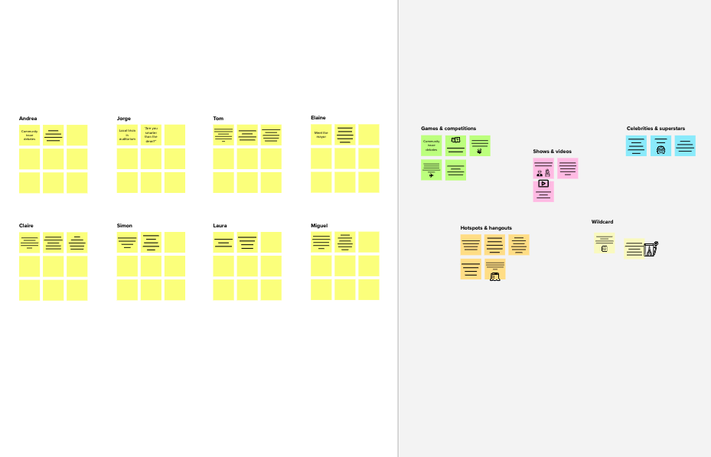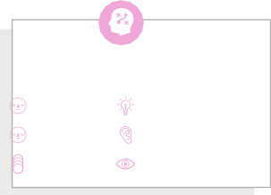

**1**

**Define your problem statement**

What problem are you trying to solve? Frame your problem as a How Might We statement. This will be the focus of your brainstorm.

**2**

**Brainstorm**

Write down any ideas that come to mind that address your problem statement.

**5 minutes**

**10 minutes**

**U*P*n*r*n*o*am*b*e*l*d*em-T*area *oresolve***

***thecustomerproblem immediately andto provideintimation duringillegalactivities***

**Mangayarkarasi S**

**Arunadevi S**

**Automated**

**chatbot**

**Feedback from**

**customers to rectify issues**

**Quick response**

**Providing**

**information about unwanted or illegal calls**

**Intimation to**

**customer after solving problem**

**Solving issues**

**on payment**

**Day and night**

**service**

**Automatic**

**connection between service provider and employee**

**kaviya M**

**Maruthambigai V**

**Displaying most**

**often asked questions in dashboard**

**Providing immediate response to the questions**

**Able to Cope up**

**Attractive with customers**

**images on from multiple**

**dashboard**

**languages**

**Key rules of brainstorming**

To run an smooth and productive session

**Chat must be**

**enabled with**

**Showing**

**information**

**service provider network quality**

**Notifications**

**Remainder about about discount**

**their recharge and offers validity**

Stay in topic.

Encourage wild ideas.

Defer judgment.

Listen to others.

Go for volume.

If possible, be visual.

**Need some inspiration?**

See a finished version of this template to kickstart your work.

[**Open example**](https://app.mural.co/template/e5a93b7b-49f2-48c9-afd7-a635d860eba6/93f1b98d-b2d2-4695-8e85-7e9c0d2fd9b9)

**C Learn how to use the facilitation tools**

Use the Facilitation Superpowers to run a happy and productive session.

[**Open article**](https://support.mural.co/en/articles/2113740-facilitation-superpowers)

**B Set the goal**

Think about the problem you'll be focusing on solving in the brainstorming session.

**A Team gathering**

Define who should participate in the session and send an invite. Share relevant information or pre-work ahead.

**Before you collaborate**

A little bit of preparation goes a long way with this session. Here’s what you need to do to get going.

**10 minutes**

[**Share template feedback**](https://muralco.typeform.com/to/CiqaHVat?typeform-source=app.mural.co)

**10 minutes** to prepare

**1 hour** to collaborate

**2-8 people** recommended

**Brainstorm**

**& idea prioritization**

Use this template in your own brainstorming sessions so your team can unleash their imagination and start shaping concepts even if you're not sitting in the same room.

**TIP**

You can select a sticky note and hit the pencil [switch to sketch] icon to start drawing!



[**Share template feedback**](https://muralco.typeform.com/to/CiqaHVat?typeform-source=app.mural.co)

## Feasibility

Regardless of their importance, which tasks are more feasible than others? (Cost, time, effort, complexity, etc.)